Basic Operations in GitHub
Operations on the GitHub website:
- Making Repository (To start a work)
- Forking (To contribute to some other repos)
- Pull Request (To merge work to the forked repo)
Complete Picture
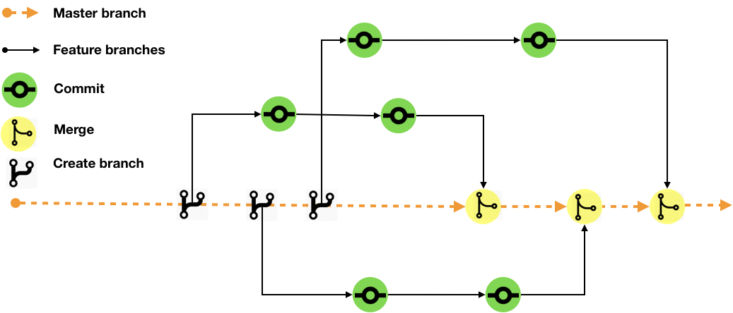
From terminal:
To view details:
git config –global user.name
git config –global user.email

To avoid putting id credentials multiple times for xxxx seconds:
git config credential.helper ‘cache –timeout=xxxx’

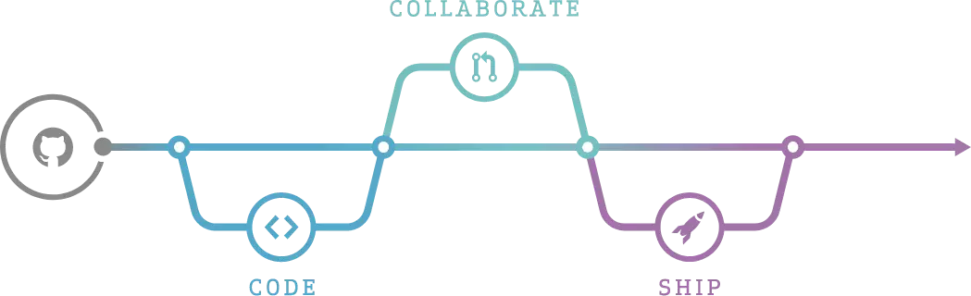
(To initiate git)
git init

(To Copy a repository from GitHub)
git clone <Copied-link-from-the-repository>
(To update the offline from the remote)
git pull

Works:
(To view the fetch-details)
git remote -v
(To view the branchs)
git branch

(To make a new branch from the present one)
git branch <new branch name>

(To rename a branch)
git branch -m <old branch> <new branch>

(To go to a branch)
git checkout <branch name>

Delete Branch:
(to delete the offline branch)
git branch -d <branch 2b deleted>
(to delete the remote branch)
git push origin –delete <branch 2b deleted>

Merge Branch:
(Branch-ii is merged with Branch-i)
git checkout <Branch-i>
git merge <Branch-ii>

Commiting (Taking a snapshot):
git add .
git commit -m “Msg+Instructions”
git status

Push to remote:
git push -u origin <Branch name>

